**CSCI 548 – Homework 2**

1. Include the following statement and sign it at the top of the report. “I, Nidhi Praveen Jain, declare that the submitted work is original and adheres to all University policies and acknowledge the consequences that may result from a violation of those rules”
2. {

"Artist": "Imitator of Raphael", done

"Image URL on Website": "http://www.nationalgallery.org.uk/upload/img/raphael-portrait-young-man-NG2510-ft.jpg",

"Artist dates": "1483 - 1520", done

"Date made": "early 16th and late 19th century",

"Dimensions": "26.6 x 21.6 cm",

"Full title": "Portrait of a Young Man",

"Acquisition credit": "Salting Bequest, 1910",

"Location in Gallery": "Not on display"

"Medium and support": "Oil on wood",

"Inventory number": "NG2510"

}

1. RDF graph

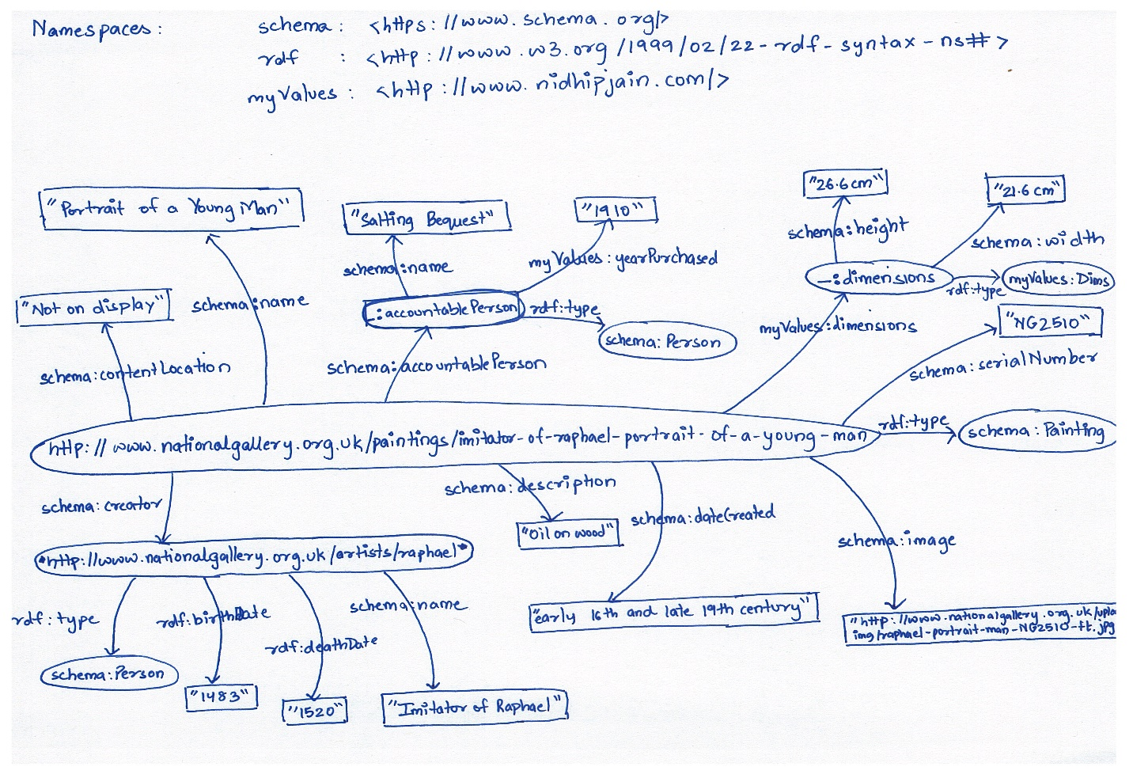

1. Turtle Triples:

@prefix schema: <https://www.//schema.org/> .

@prefix rdf: <http://www.w3.org/1999/02/22-rdf-syntax-ns#> .

@prefix myValues: <http://www.nidhipjain.com/> .

<http://www.nationalgallery.org.uk/paintings/imitator-of-raphael-portrait-of-a-young-man> schema:creator <http://www.nationalgallery.org.uk/artists/raphael> .

<http://www.nationalgallery.org.uk/paintings/imitator-of-raphael-portrait-of-a-young-man> rdf:type schema:Painting .

<http://www.nationalgallery.org.uk/artists/raphael> rdf:type schema:Person .

<http://www.nationalgallery.org.uk/artists/raphael> schema:birthDate "1483" .

<http://www.nationalgallery.org.uk/artists/raphael> schema:deathDate "1520" .

<http://www.nationalgallery.org.uk/artists/raphael> schema:name "Imitator of Raphael" .

<http://www.nationalgallery.org.uk/paintings/imitator-of-raphael-portrait-of-a-young-man> schema:description "Oil on wood" .

<http://www.nationalgallery.org.uk/paintings/imitator-of-raphael-portrait-of-a-young-man> schema:dateCreated "early 16th and late 19th century" .

<http://www.nationalgallery.org.uk/paintings/imitator-of-raphael-portrait-of-a-young-man> schema:image <http://www.nationalgallery.org.uk/upload/img/raphael-portrait-young-man-NG2510-ft.jpg> .

<http://www.nationalgallery.org.uk/paintings/imitator-of-raphael-portrait-of-a-young-man> schema:serialNumber "NG2510" .

<http://www.nationalgallery.org.uk/paintings/imitator-of-raphael-portrait-of-a-young-man> schema:contentLocation "Not on Display" .

<http://www.nationalgallery.org.uk/paintings/imitator-of-raphael-portrait-of-a-young-man> schema:name "Portrait of a Young Man" .

_:accountablePerson a schema:Person .

<http://www.nationalgallery.org.uk/paintings/imitator-of-raphael-portrait-of-a-young-man> schema:accountablePerson _:accontablePerson .

_:accountablePerson rdf:type myValues:Dims .

_:accountablePerson schema:name "Salting Bequest" .

_:accountablePerson myValues:yearPurchased "1910" .

<http://www.nationalgallery.org.uk/paintings/imitator-of-raphael-portrait-of-a-young-man> myValues:dimensions _:dimensions .

_:dimensions schema:height "26.6 cm" .

_:dimensions schema:width "21.6 cm" .

1. Main page where I have entered the turtle triples:

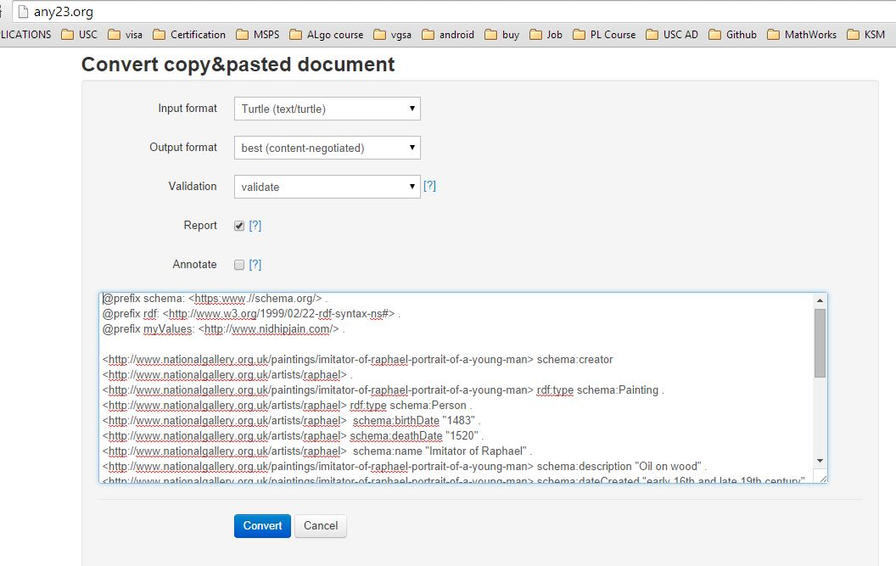

Validation success 1:

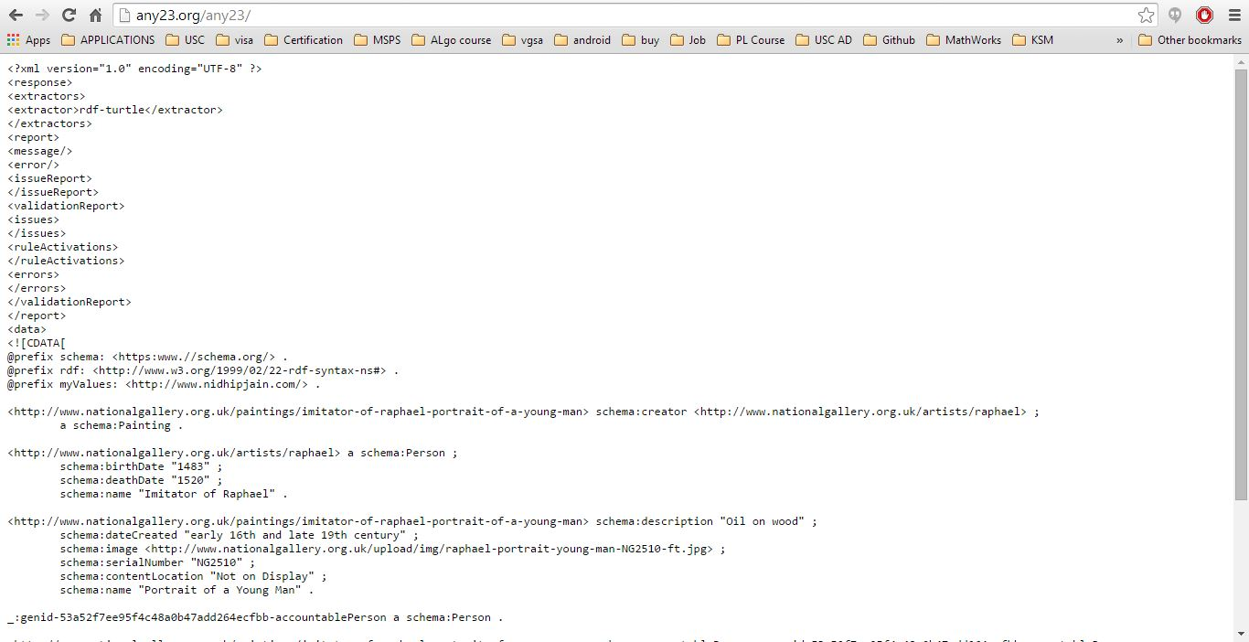

Validation success 2:

